PM-04-PS03
Mzansi Bank FICA Compliance Automation
Robotic Process Automation Solution

ASSESSMENT EVIDENCE PACKAGE

https://github.com/TheFish1011/PM-04-PS03.git
Author | Estian Visagie
Course Code | PM-04-PS03
Document Version | v1.0
Submission Date | 27 April 2026

1. Selected RPA Platform
UiPath was selected due to its strong enterprise adoption within financial institutions, robust security features, and extensive library of prebuilt automation activities. It supports both low-code and custom development, making it suitable for compliance-heavy environments such as banking. Additionally, its integration with Orchestrator enables centralized control, logging, and scheduling.

2. Development Environment Setup
- Installed UiPath Studio
- Created new Process project
- Created workflows: Main.xaml, ProcessClient.xaml, ValidateSAID.xaml
- Created Config.csv
- Verified dependencies
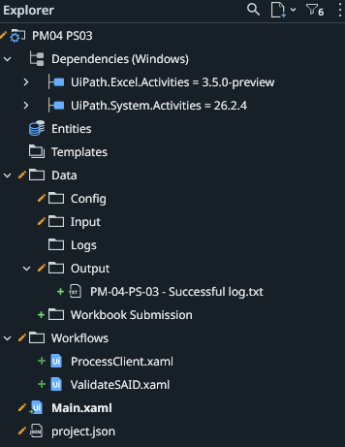

3. Initial Workflow
Basic workflow created with config loading and logging.
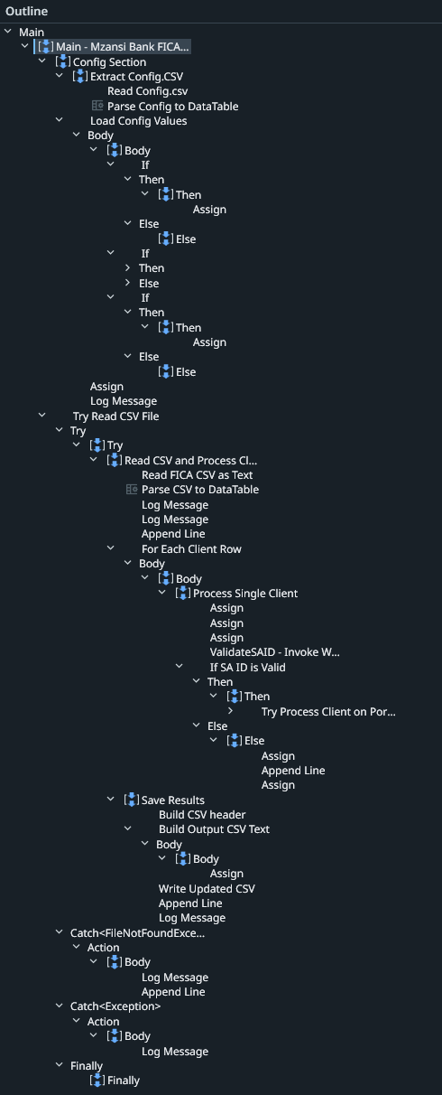

4. Process Design & Main Workflow
Phase 1 — Configuration Loading
Step | Activity | Description
1.1 | Read Config.csv | Reads the configuration file from  Config\Config.csv
1.2 | Parse Config to DataTable | Parses the raw CSV text into a structured  dt_Config  DataTable
1.3 | Load Config Values | Iterates each row and maps keys to variables:
 | →  InputFilePath | Path to the client input CSV
 | →  PortalURL | URL of the FICA compliance portal
 | →  OutputFolder | Directory where output files will be saved
1.4 | Set Log File Path | Constructs the log file path as  OutputFolder\processing_log.txt
1.5 | Log Config Summary | Logs loaded config values to the Studio output panel

Phase 2 — Data Ingestion (wrapped in Try/Catch)
Step | Activity | Description
2.1 | Read FICA CSV as Text | Reads the input CSV from  str_InputFilePath
2.2 | Parse CSV to DataTable | Converts raw text into  dt_ClientData  DataTable
2.3 | Log Process Start | Logs total record count and timestamps to both the Studio log and the  .txt  log file

Phase 3 — Client Processing Loop (For Each Client Row)
For every client record in dt_ClientData:
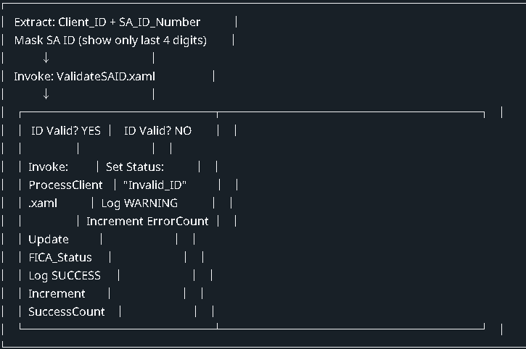

Sub-workflow calls:
- ValidateSAID.xaml — Validates the SA ID format/checksum → returns bool_IsValid
- ProcessClient.xaml — Submits the client to the FICA portal → returns str_FICAResult

Phase 4 — Save Results
Step | Activity | Description
4.1 | Build CSV Header | Sets header:  Client_ID, Full_Name, SA_ID_Number, FICA_Status
4.2 | Build Output CSV Text | Iterates  dt_ClientData  and builds the full CSV string
4.3 | Write Updated CSV | Writes to  OutputFolder\FICA_Compliance_Data_Updated.csv
4.4 | Log Completion | Logs final counts (Success & Errors) to both log targets

Exception Handling Strategy
Scope | Exception Type | Handling
Outer | FileNotFoundException | Logs CRITICAL error — process cannot continue, terminates gracefully
Outer | General Exception | Logs unexpected error message
Per Client | General Exception | Sets FICA_Status =  "Error"  , logs ERROR entry, increments ErrorCount —  continues to next client
Invalid ID | Business Exception | Sets FICA_Status =  "Invalid_ID"  , logs WARNING, increments ErrorCount —  continues to next client

Data Flow Summary

Config.csv → dt_Config → Runtime Settings

│

ClientData.csv → dt_ClientData → Per-Row Processing

│

ValidateSAID.xaml ──┤
ProcessClient.xaml ──┤

│

FICA_Compliance_Data_Updated.csv ←
processing_log.txt ←

